Windows XP and Speech Recognition
By Vinny La Bash, Member of the Sarasota PCUG, Florida
vlabash@comcast.net

I used to watch Star Trek in envy as the ship’s computer “listened” to the crews’ instructions and responded with perfect understanding. Speech recognition is not there yet, but why let lack of perfection stop us from trying?
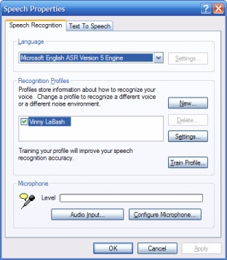
Speech recognition has come a long way since it was first introduced to personal computers. On a basic level speech recognition is the process of converting an acoustic signal, captured by a microphone, and transforming it into words on a document.. The procedure is highly technical, but you don’t have to understand its inner mysteries to use it any more than you need to know how an automobile is designed in order to drive it.

Many of those who have Windows XP installed believe that speech recognition is built into XP. That’s because many PC vendors install Microsoft’s speech recognition software along with XP as a convenience to customers. Click on the Start button and go into Control Panel. Locate the Speech icon and open it with your mouse. A dialog box will appear. If it has a Speech Recognition tab, the program is already installed.

If speech recognition is not installed you have several options. You can buy Microsoft Plus! for Windows XP for about $30. This is the least expensive option. You get some additional goodies with the package for your money, but they’re not important to our discussion.

If you have Microsoft Word or Office installed, and you don’t have the Speech Recognition tab in the above mentioned dialog box, the program was not installed by default. Fortunately, it’s easy to install from Word. From the Tools menu open the Speech option. Choose Yes when you’re asked if you want to install the program. You will probably need the installation disk.

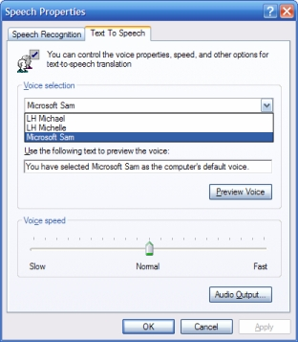
You didn’t think you were finished, did you? The program needs to be trained like a puppy dog. It won’t mess your carpet, and you don’t need to take it for a walk, but you do have to show it how to speak appropriately.. The program will assist you with the proper position of your microphone, and it will help you create a profile.

The profile stores your unique speech patterns and any pronunciation quirks you may have. You can use one of three different voices as your default, Michelle, Michael, or Microsoft Sam. They could all stand some improvement, but I prefer Sam.

All that’s left is for you to “train” the program to convert your speech into words on the document. Start the training from the Speech option in the Tools menu. You will be offered a selection of different texts to read, ranging from Bill Gates’ book “The Road Ahead” to Edgar Allen Poe’s “Fall of the House of Usher”. The more text you read, the more accurately the program will convert your speech to text. In time, you can experience an accuracy rate better than 98%.

Get a high quality microphone. A noise-canceling headset can be purchased for less than $50. Speak naturally, the same way you would speak to another person in a normal conversation. Don’t try training the program as if it were a child or an obstinate pet. That produces very poor results and needless frustration.

Even with all the progress in the last decade, speech recognition is still far from perfect. So why bother using it? It’s an excellent tool for creating the first draft of a manuscript of any length... Dictation is a lot easier than using the keyboard and mouse to make text entries. If you take the time to learn how to correct errors through the program’s editing utility, you will save time, especially if you fall into the camp of lousy typists as most of us do.

Speech control allows many people access to computers who could otherwise not use them through the conventional keyboard and mouse interface. Those who suffer from visual impairments, repetitive strain injuries or other physical limitations have found new opportunities through speech recognition. You may be amazed at what you can accomplish when you unleash the power of your voice.

There is no reason why speech recognition has to be confined to computers. This technology is slowly finding its way into homes, automobiles, factories, and wherever the marketplace dictates.

Speech recognition, like video editing, requires a lot of computer power. Have at least one gigabyte of memory and a 2.0 MHz processor as a bare minimum.

There is no restriction against any non-profit group using this article as long as it is kept in context with proper credit given the author. The Editorial Committee of the Association of Personal Computer User Groups (APCUG), an international organization of which this group is a member, brings this article to you.

